Training Guide for Sales and Customer Support

Background:
- Background information: We are a delivery food company system
- Problem Statement: We need to saving costs and delivery times issue that we have in the first 2 /5 meters
- Product Goals: With our robot we will save cost and we will increase the delivery times.

Market background:
Write a short description of your market and audience:
- Our ideal customer is somebody that is ordering food or items and want a delivery at home
  - Outline your target audience: Who love food, who love the ecommerce
  - Describe your targeted market: We will do a full rollout .

- Competitor's target audience: "System delivery food and Urban delivery".Source: https://postmates.com/
Competitor's market share: 7%Source: craf.co Market Share and Competitor Report

Product Background:
Describe your product and what sales need to know about it:
- GPS Tracker this features permits to the customer to see where the robots it is.
- Anti Theft Mode with this features nobody can stoile the food inside the robots
- Pernolize delivery with this featues the customer can pesonalize the order
- We may have sometimes the robot stuck anbd we need to use our software to unstuck.

Here is out lovely product :
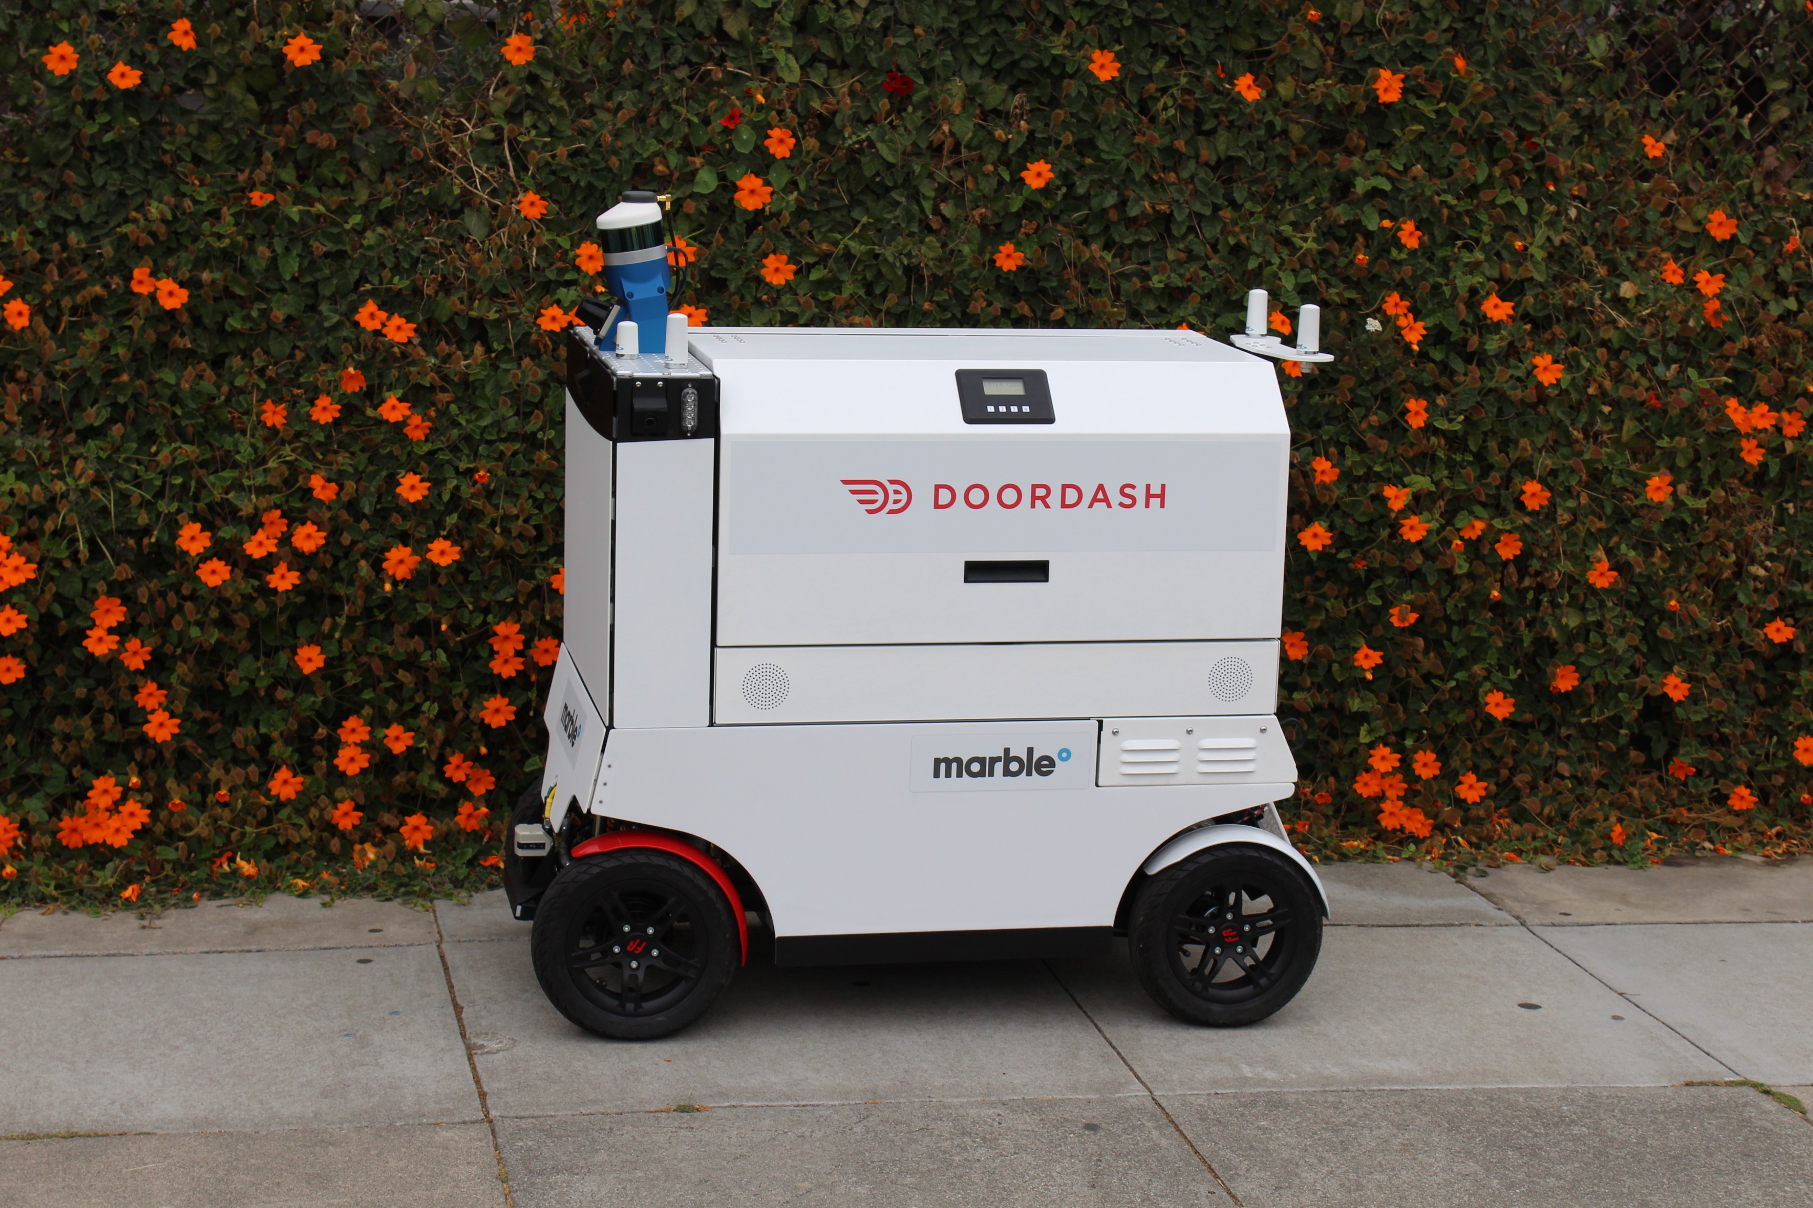

Pricing:
Describe your pricing:
- is freemium the app is free but we will add some extra payment to our customer
- For every new customer the first oder will be 20% less
- No delivery for who order more then 20$

